Ty Wheeler

CS 360

4/12/25

App Launch Plan

*Application Description*  
 The “goal weight tracker app” is a user-friendly Android application designed to help individuals track their weight over time and monitor progress toward their fitness and health goals. Users can create accounts, log weight, update or remove log entries, and see their progress with a clean, grid-based display. One of the key features is the ability for users to receive SMS alerts when goal milestones are reached which helps users stay motivated and on track. This app is ideal for fitness enthusiasts or anyone else interested in developing and maintaining a healthy lifestyle. Using local storage and implementing simple visual organization, this app offers a lightweight and offline solution that doesn't require an internet connection or any sort of subscription to function properly. The icon is a minimalistic, modern digital scale with a green checkmark overlaid to represent progress and success. The colors will be calming and health oriented to symbolize wellness.

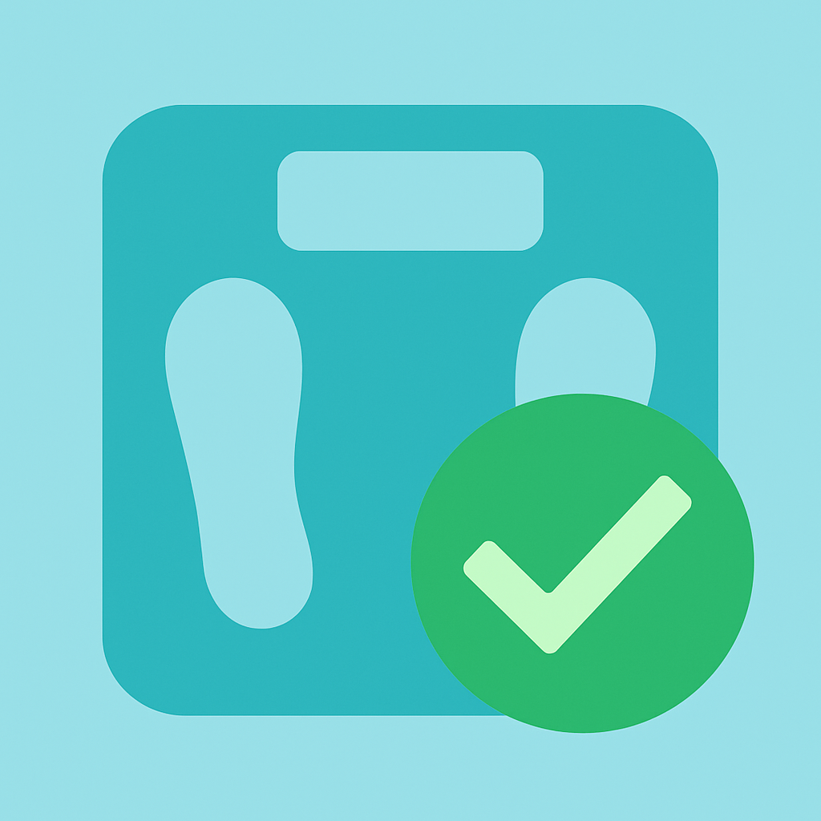

*Android Version Compatibility*

For Android version compatibility the minimum SDK version will be 21 and the target SDK version will be set to 34. Setting the minimum SDK to 21 ensures compatibility with over 95% of Android devices in use currently. The target SDK is set to the most current version to take advantage of the latest security and system enhancements introduced in Android 14 which ensures long term viability. Compatibility considerations were carefully implemented to meet modern Android standards while maintaining backward compatibility through various condition checks.

*App Permissions*

The Weight Tracking app requests only one permission essential to its core functionality which is the SEND_SMS permission. This allows the app to send automated SMS notifications to the user to celebrate when a user logs their goal weight. The permission is requested in the separate menu at the top right of the main screen, activity_data.xml, and only after the user has chosen to enable SMS notifications will they then receive said notifications. If the user denies the permission then the app continues to function fully. The app also declares the use of telephony features in the manifest to ensure it can operate properly on devices capable of sending SMS messages. No other unnecessary permissions are requested which keeps user privacy a priority.

*Monetization Plan*

At launch the app will be free to use and will not include any advertisements. This approach is designed to support initial user acquisition by reducing barriers to entry and ensuring a clean, distraction-free experience. As the app builds a loyal user base, there is potential to introduce additional features through a freemium model. These enhanced capabilities could include cloud sync, AI based meal prep and workout reccomendations and integration with popular fitness tracking devices. These premium features would be available either through a one-time in-app purchase or a monthly subscription plan. Despite these potential expansions, the core functionality of the app will remain free. This ensures that the app stays accessible and builds a user base that trusts it’s reliability and stability.